Green Bay’s Only Children’s Hospital
Your child is in the best of hands.
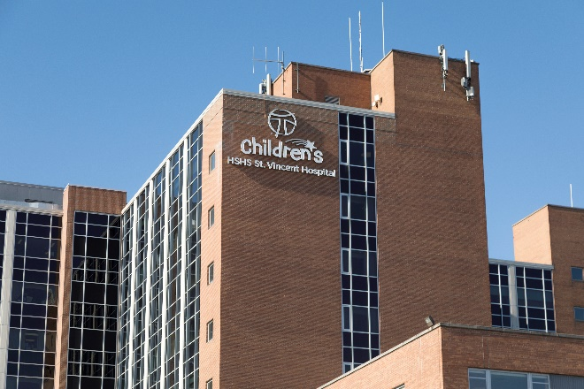
SVCH_Exterior Sign-4

As a parent, grandparent or caregiver, you can breathe a sigh of relief knowing you don’t have to travel to Milwaukee for expert care for kids. You have access to a designated children’s hospital in Green Bay!

Located inside the walls of HSHS St. Vincent Hospital, HSHS St. Vincent Children’s Hospital is proud to be Green Bay’s first and only children’s hospital – where we deliver exceptional health care to children and their families. We’ve been serving kids for more than 100 years at HSHS St. Vincent Hospital and that’s why, in 2015, we became a designated children’s hospital.

At HSHS St. Vincent Children’s Hospital, we’re professionally and personally devoted to you and your kids. We serve children of all ages throughout Northeast Wisconsin, the Lakeshore and Michigan’s UP. On our hospital campus, we provide pediatric emergency care, pediatric hematology and oncology (care for blood disorders and cancers), a pediatric unit and a pediatric intensive care unit (PICU), a level III newborn intensive care unit (NICU) and specialized child life care. With our medical partners like Prevea Health, we also offer general pediatric care and a wide range of specialty care for kids in both the hospital and clinic settings.

Since becoming a designated children’s hospital, we recognized the need to update our facility to best serve the needs of children. That’s why, in 2016, we started planning for fundraising and construction to make sure every detail here is even more tailored to kids. As a non-profit organization, it’s thanks to the generosity of our communities that renovating HSHS St. Vincent Children’s Hospital has been possible. We were beyond excited to begin a multi-phased construction project for HSHS St. Vincent Children’s Hospital after completing our Join the Fight community fundraising campaign. A lot of work went into fundraising for the project, and community donors saw the value of providing this level of care to kids. They helped make our vision of a children’s hospital come true. That vision was to remodel our facility to incorporate modernized spaces, technology and designs specifically for children and the unique care they require.

Phase one of the construction project was a redesign of the emergency department by carving out spaces just for kids – opening our new pediatric emergency center at HSHS St. Vincent Children’s Hospital in 2019. Updates to the pediatric emergency center included a new waiting room and play area specifically designed for children, new treatment rooms equipped with new technologies and elements specifically designed for children, and a new nurse’s station with specialized monitoring of our patients.

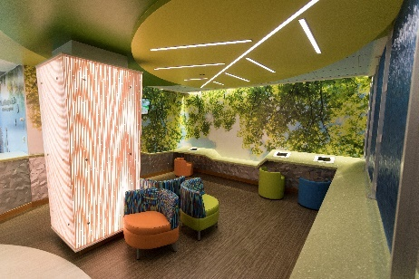
SVCH ED 43
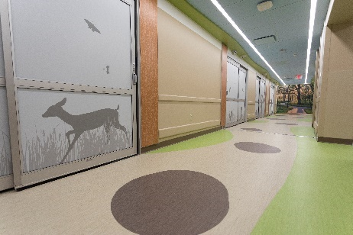
SVCH ED-26
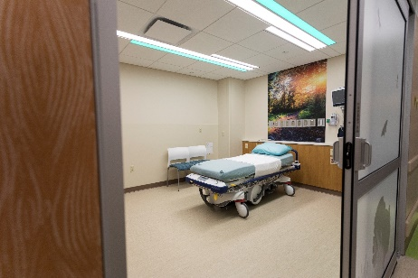
SVCH ED 14

Due to the pandemic, the next phase of construction was delayed but it has resumed and is near completion. This includes the reconfiguration of the entire pediatric floor where we have a new pediatric unit and pediatric intensive care unit (PICU).

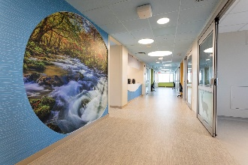
SVCH_PICU-12
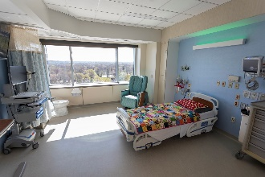
SVCH_PICU-1
The pediatric units are bright and welcoming. We wanted to provide children and young adults a healing environment in which they feel at home, so all patient rooms, hallways and gathering spaces feature visuals of the natural landscapes and beautiful colors found in Northeast Wisconsin.

The new PICU has increased capability to care for critically ill children. From rooms that are specifically designed for infection control and safety to updated rooms with advanced technology and equipment, the PICU offers families a comfortable stay and allows our pediatric intensivists to provide the highest level of pediatric care in our region. The new pediatric unit, next to our PICU, allows for easy transfer between the two units as needed. All kid-friendly rooms feature color changing lights, high-quality monitoring systems, sound-proofing, private bathrooms and sleep accommodations for parents. Advanced technology also allows video EEG monitoring to be done in any room on the floor, decreasing the need to move patients from one room to another for certain procedures.

When you step off the elevators to our pediatric floor, you are greeted by a giant interactive TV wall designed to help patients feel like they are somewhere else outside of the hospital. Patients and families can experience different scenes such as a flickering campfire and fireflies at night, which we hope will provide a bit of comfort while they spend time with us. The TV also gives children the opportunity to get outside of their room to play games or watch a movie on the big screen. It’s not only beautiful to look at and fun to play with, but it provides the mental and physical benefits that come with patients moving around and interacting with others.

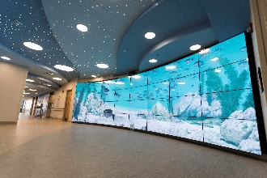
SVCH_Interactive Monitor Wall4
HSHS St. Vincent Children’s Hospital is the only hospital in the Midwest to have a multi-screen interactive TV wall. We are proud to have unique technology like this for the kids and their families, and it’s all thanks to community donations.

Our Child Life team has a new center with much needed storage for their games, toys and sterilizing equipment. The only full-time Child Life service offered in Northeast Wisconsin, these amazing professionals provide age-specific education and play for distraction. It is this team’s priority to make sure patients and their siblings understand what’s going on with their care, while offering plenty of opportunity to play throughout their stay.

The final phase of construction is set for completion in summer 2022. A new family lounge will offer a place for parents or caregivers to take some time for themselves outside of their child’s room, and a new teen lounge will be equipped with video and audio features to provide an “escape.” A private mother’s room for breastfeeding and a laundry room will also be available for families.

The entire pediatric floor is equipped with advanced security which includes cameras and locked entrances to ensure the safety of our patients at all times.

At HSHS St. Vincent Children’s Hospital, your kids are in the best of hands. They’re at the center of everything we do. After all, your kids are the reason we exist. Our dedicated pediatric teams continue to strive for excellence and evaluate the needs of our patients and community to offer an expert level of pediatric care to families in need.

